

|  |
| --- |
| ITECH3208 – PROJECT 1  Sprint – 1 Engagement and Contribution report  Submitted to : Nityansh Rattan |
| |  |  |  | | --- | --- | --- | | Harmanpreet Singh Bedi | 9/15/24 | 30410228 | |

Table of Contents

Project name 3

Software used 3

Contribution towards Project 3

Evidences 3

Evidence 1 3

Evidence 2 8

Evidence 3 9

# Project name

Designing a comprehensive E-Commerce website for XYZ Medical Company

# Software used

* Documentation : Microsoft Word
* Tracking Sprint Progress : Jira Board (Timeline and Backlog)
* Mockups and Prototypes : Figma
* Coding : Visual Studio Code
* Localhost backend server : XAMPP
* Testing : Web Browsers like Google Chrome, Edge and Firefox
* Meetings : Microsoft Teams

# Contribution towards Project

As a team member and project lead of the development team for XYZ Medical Company, I contributed towards the completion of first sprint.

Goals of first sprint :

* Gather specifications from the client.
* Document that requirements and specifications in Project Scope.
* Create mockups, burn up and burn down charts.

My role in this sprint :

1. To assign roles to the team members and start the sprint.
2. Handle all the meetings of this sprint.
3. Create mock-up pages for Login, Home and Products pages.

# Evidences

## Evidence 1

I assigned the user stories created by Devansh to all the team members. After that I started the sprint and kept the track of the Jira board and task progress .

Fig. 1 Timeline of user stories

Fig. 2 Backlog sprint

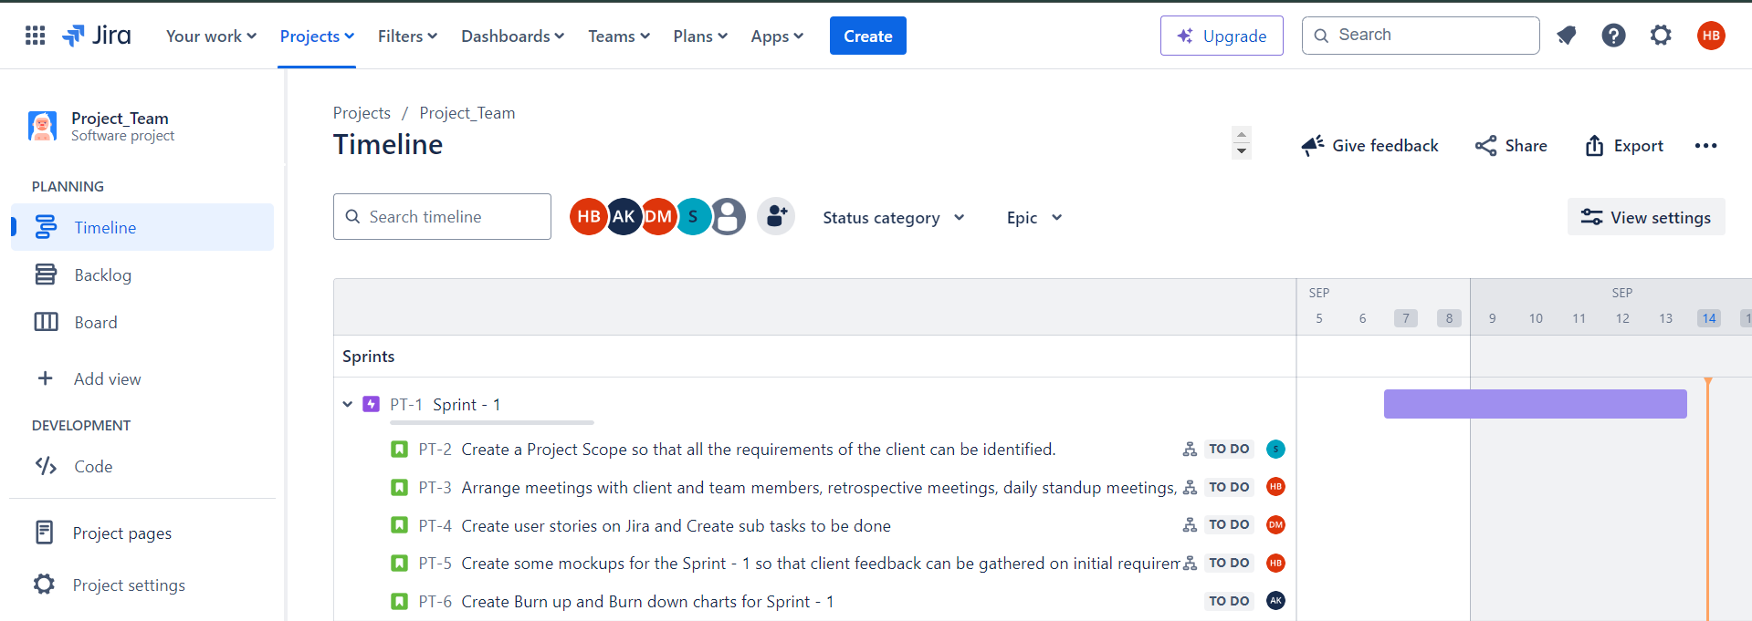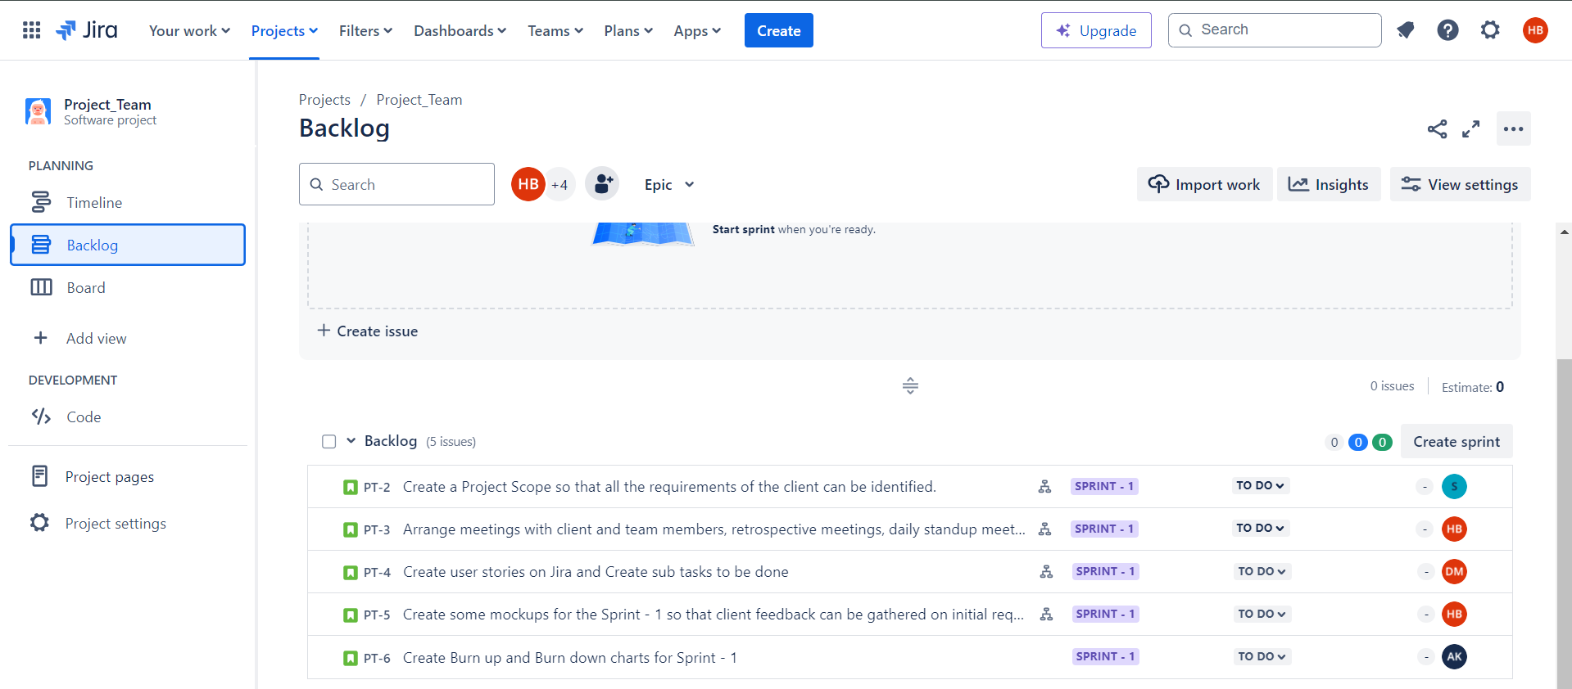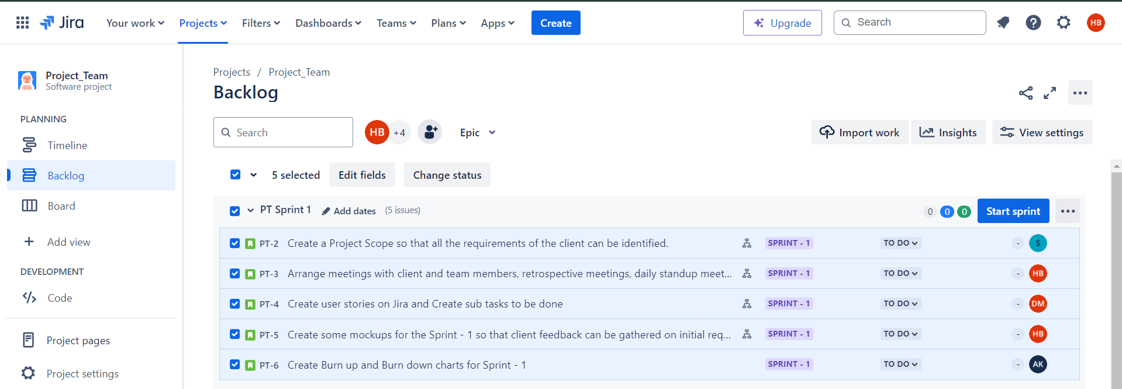

Fig. 3 Backlog after creating sprint

Fig. 4 Starting the sprint

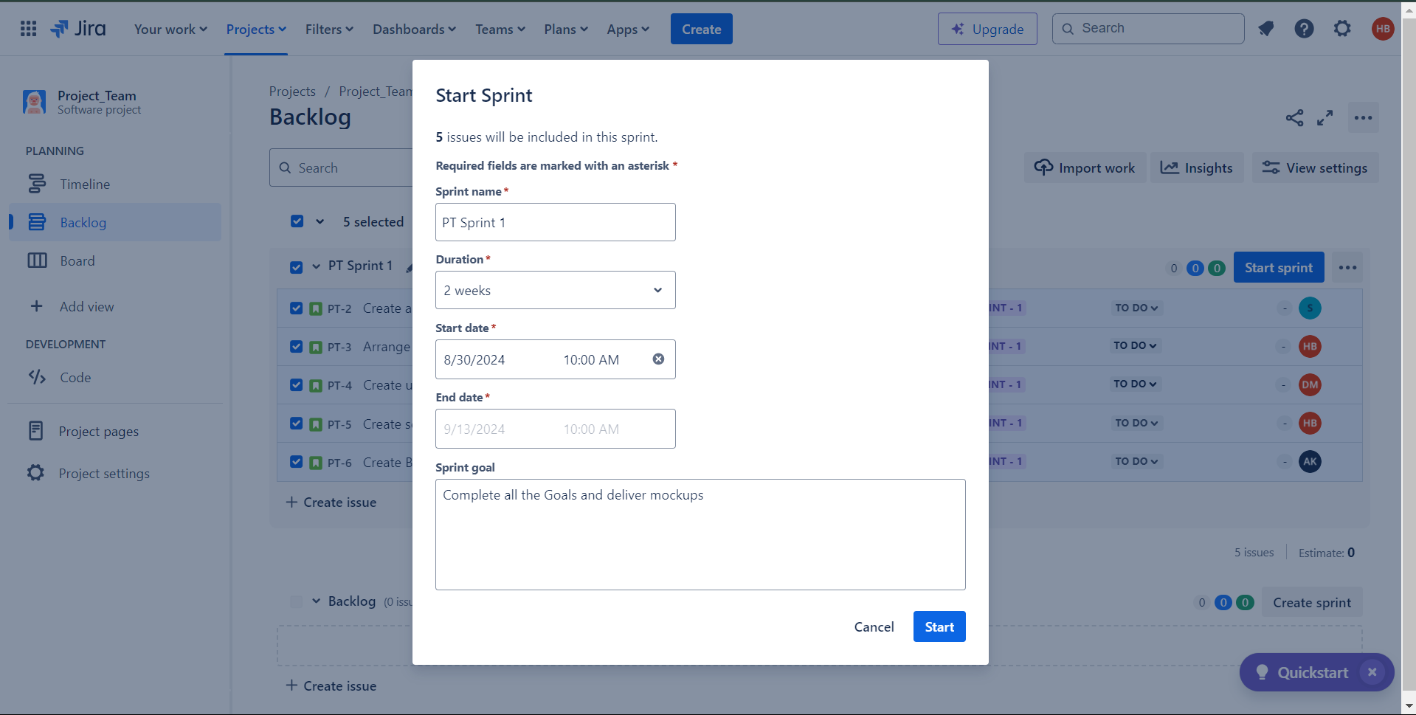

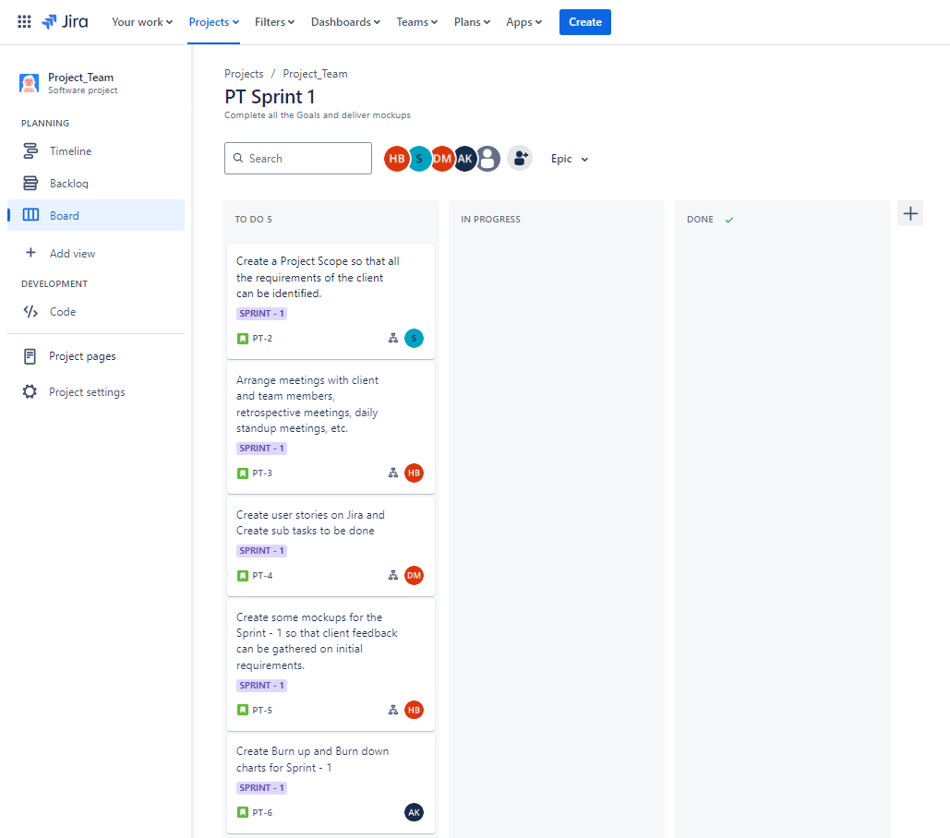

Fig. 5 Jira Board

Fig. 6 Jira Board

Fig. 7 Jira Board

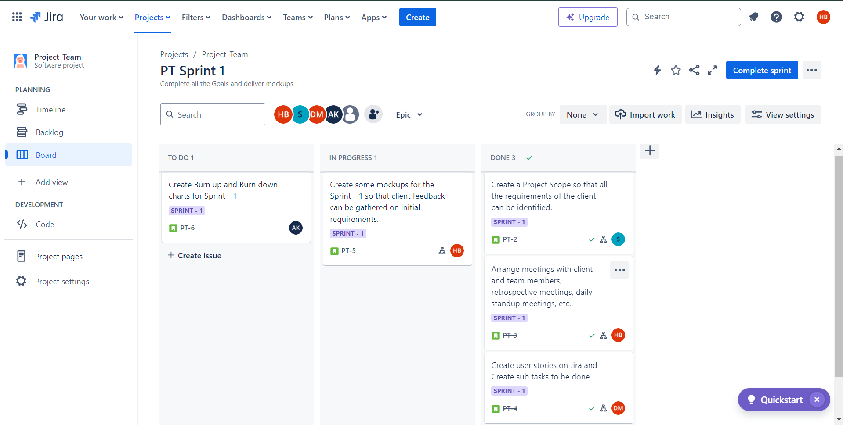

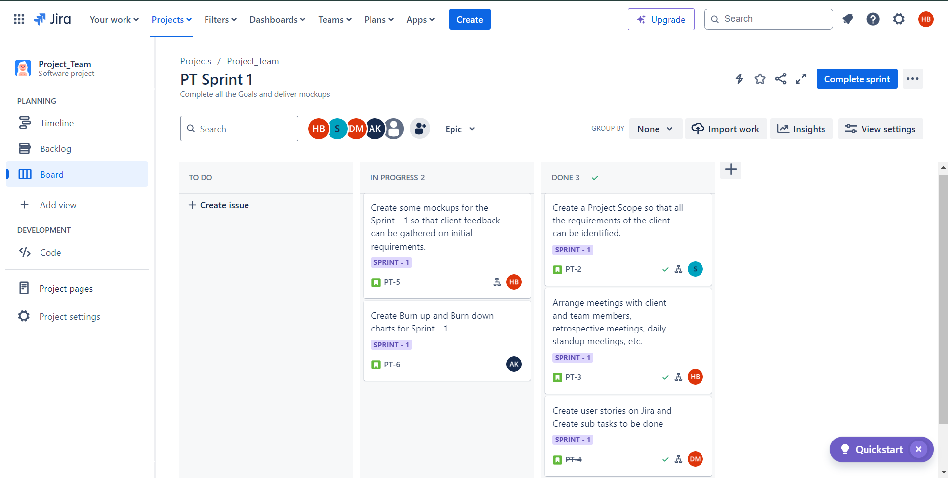

Fig. 8 Jira Board

Link to the Jira board : https://itech3208.atlassian.net/jira/software/projects/PT/boards/2

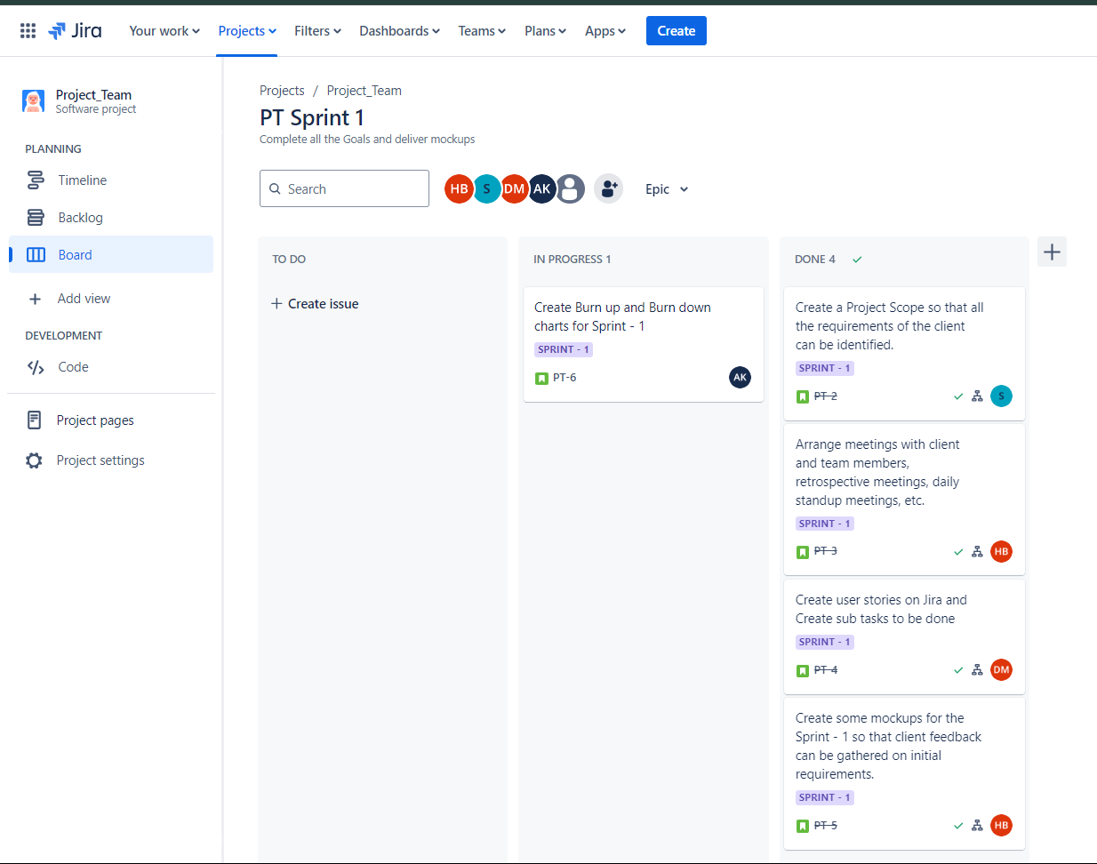

## Evidence 2

I conducted client feedback meeting where the project scope was finalized.

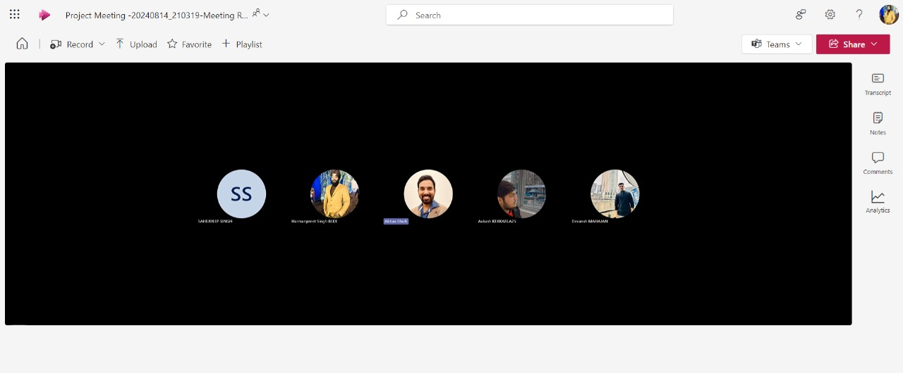

Fig. 9 Client feedback meeting

Also, I conducted a retrospective meeting at the end of the project to discuss the tasks and challenges faced by all the team members.

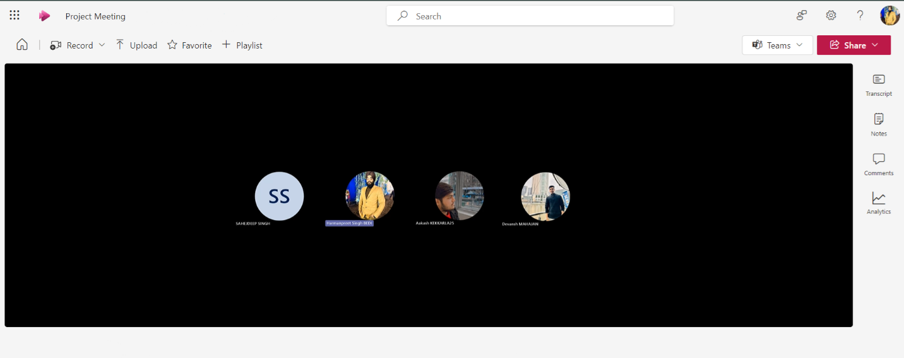

Fig. 10 Retrospective meeting

|  |  |
| --- | --- |
| **Questions** | **Answers of members** |
| What I did ? | Harmanpreet Singh Bedi : I arranged all the meetings during the sprint, and made mock-up pages once the scope was finalized by the client. |
| Devansh Mahajan : I was responsible for making user stories and tasks on Jira board that could be later assigned to every member. |
| Sahejdeep Singh : I documented all the requirements of the client into a Project Scope, along with helping my team member Harman with mock-ups. |
| Aakash : I am making burn up and burn down charts for the user stories that are on the Jira Board. |
| What are the remaining tasks ? | Harmanpreet Singh Bedi : As of now, no remaining tasks are left. |
| Devansh Mahajan : No remaining tasks. However, optimization can be done of the product and sprint backlog. |
| Sahejdeep Singh : No remaining tasks left. |
| Aakash : Charts are still pending. |
| What challenges I faced in my tasks ? | Harmanpreet Singh Bedi : The major challenge was to gather all the team members for meetings as everyone was having their own schedule. |
| Devansh Mahajan : No such challenge faced. |
| Sahejdeep Singh : I was new to Figma so it took a little bit of time to get familiar with it. |
| Aakash : No challenge. |

## Evidence 3

I created mock-ups of Login, Home and Products pages on Figma once the project scope was finalized.

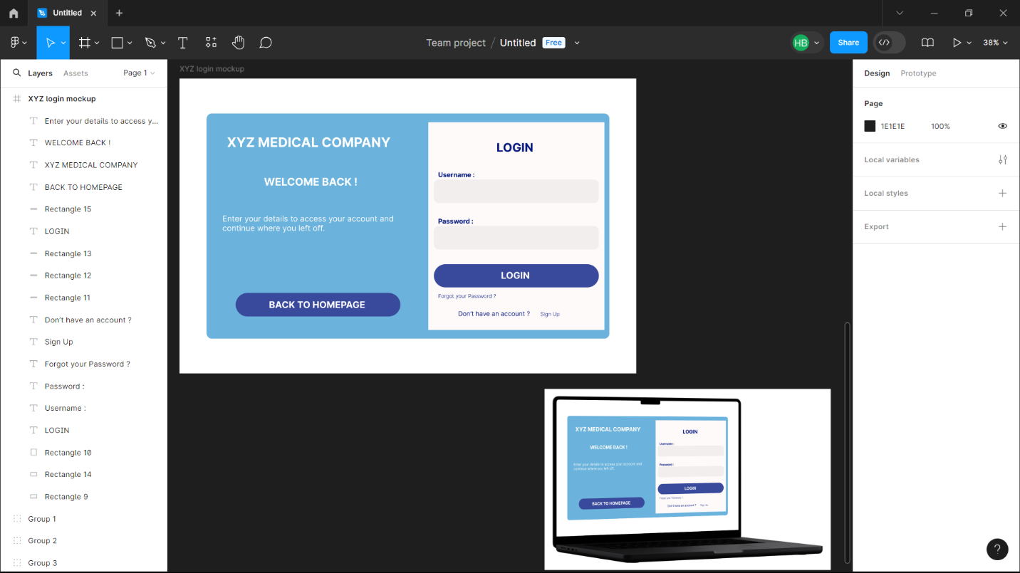

Fig. 11 Login page mock-up

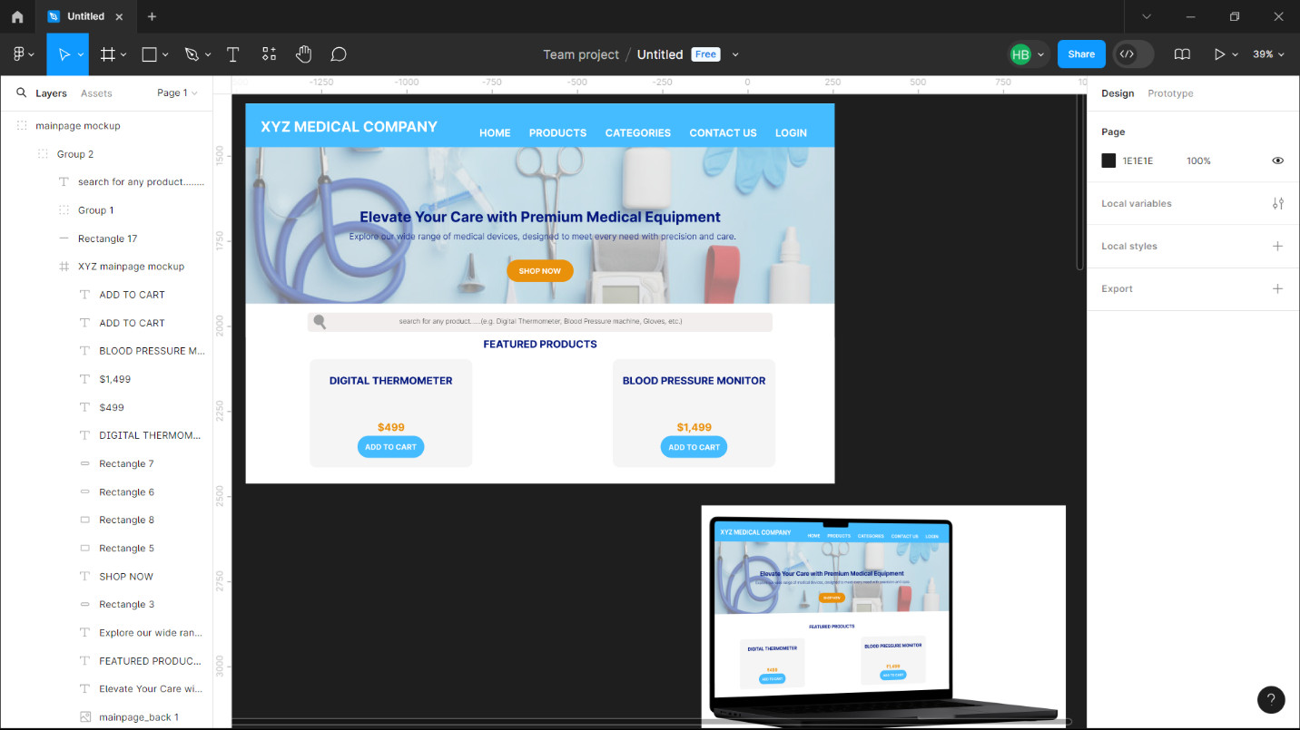

Fig. 12 Home page mock-up

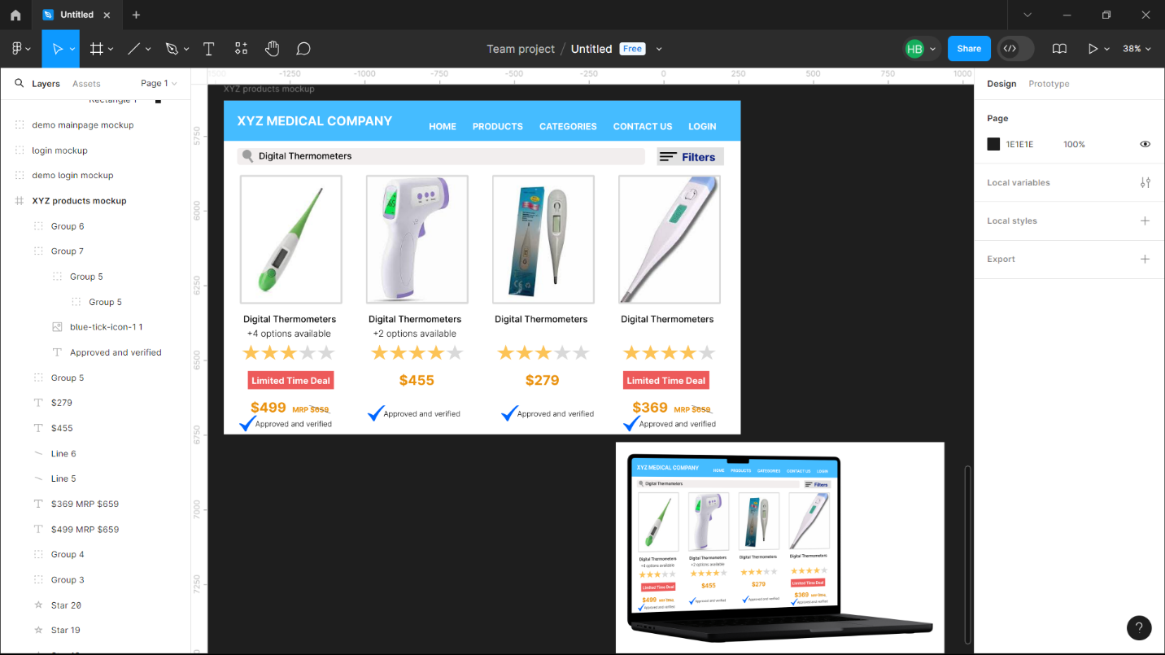

Fig. 13 Products page mock-up